**Jenkins installation and setup on Ec2 instance**

1. sudo apt update
2. sudo apt upgrade
3. sudo apt install openjdk-21-jdk
4. sudo wget -O /etc/apt/keyrings/jenkins-keyring.asc \

https://pkg.jenkins.io/debian-stable/jenkins.io-2023.key

5.echo "deb [signed-by=/etc/apt/keyrings/jenkins-keyring.asc]" \

https://pkg.jenkins.io/debian-stable binary/ | sudo tee \

/etc/apt/sources.list.d/jenkins.list **>** /dev/null

6.sudo apt update

7.sudo apt install jenkins

Check for system processes

8. ps -ef | Grep jenkins

ubuntu@ip-172-31-26-158:~$ ps -ef | grep jenkins

jenkins 8464 1 11 18:44 ? 00:00:18 /usr/bin/java -Djava.awt.headless=true -jar /usr/share/java/jenkins.war --webroot=/var/cache/jenkins/war --httpPort=8080

ubuntu 8638 1040 0 18:46 pts/0 00:00:00 grep --color=auto jenkins

Login to Jenkins: IP:8080

ubuntu@ip-172-31-26-158:~$ sudo vim /var/lib/jenkins/secrets/initialAdminPassword

Install Docket plugin

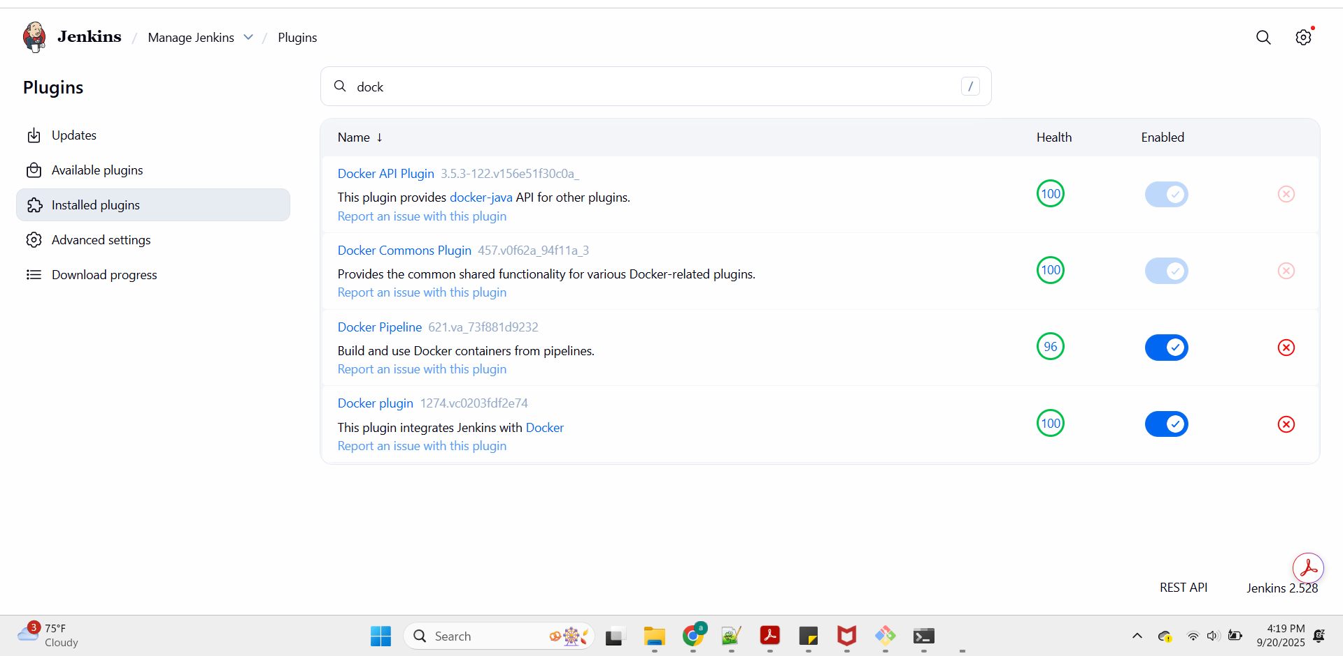

https://github.com/padmaja92/DevopsEngineerRepository/blob/main/Jenkins/Jenkins

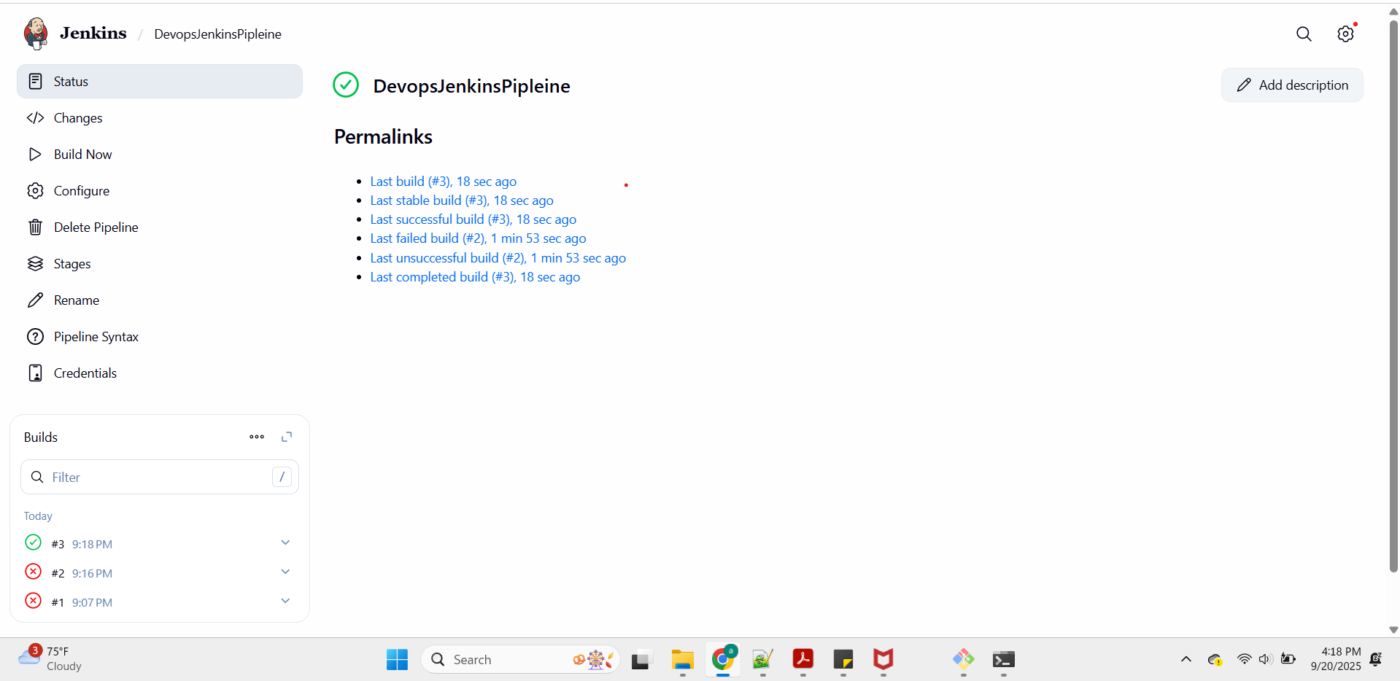

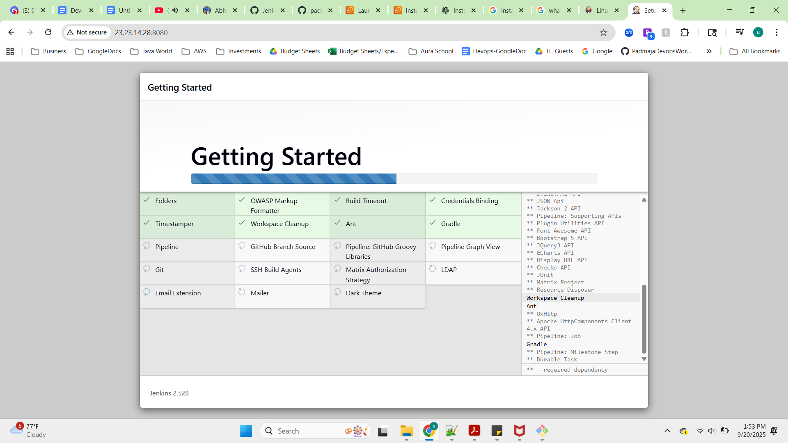

**Jenkins MAster and Docker Container architecture for Ci/CD pipeline**

1. **Install Docker sudo sudo apt install** [**docker.io**](http://docker.io)
2. **By default users dont have access to Docker Deomn single processing system , so we are adding jenkins and ubuntu access to docker group**

**sudo -su (super user)**

**usermod -aG docker jenkins**

**usermod -aG docker ubuntu**

**systemctl restart docker**

**Different users**

**ubuntu@ip-172-31-26-158:~$ logout**

**root@ip-172-31-26-158:/home/ubuntu# su - jenkins**

**jenkins@ip-172-31-26-158:~$**

**Ubuntu user**

**Root user**

**Jenkins has default user when you install jenkins on your instance**

**$ docker run hello-world**

**Hello from Docker!**

**This message shows that your installation appears to be working correctly.**

**To generate this message, Docker took the following steps:**

**1. The Docker client contacted the Docker daemon.**

**2. The Docker daemon pulled the "hello-world" image from the Docker Hub.**

**(amd64)**

**3. The Docker daemon created a new container from that image which runs the**

**executable that produces the output you are currently reading.**

**4. The Docker daemon streamed that output to the Docker client, which sent it**

**to your terminal.**

**To try something more ambitious, you can run an Ubuntu container with:**

**$ docker run -it ubuntu bash**

**Share images, automate workflows, and more with a free Docker ID:**

**https://hub.docker.com/**

**For more examples and ideas, visit:**

**https://docs.docker.com/get-started/**

**If you have any issues logging into Jenkins- restart**

**IP:8080/restart**

